Measuring for curtain width
Always measure the curtain track or pole width, not the window. If fitting a new track or pole, this should extend 15cm to 30cm either side of the window (to allow the curtains to be stacked back off the window) and 12cm to 15cm above the window recess.
If you have a rail with a centre overlap, measure the rail as above then measure the overlap and add the two measurements together.
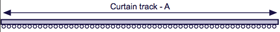
Measure from end to end - A
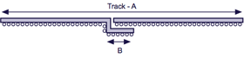
Measure from end to end with overlap - A + B
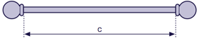
Measure used pole only - C

Measuring for curtain drop
Curtains are best hung either to the floor, to a sill or below the sill. We recommend that curtains finish either:-
A) 1cm above the floor
B) 15-20cm below the sill (or 2cm above the radiator)
C) 1cm above the sill
Always measure in at least 3 positions across the track or pole as floors and sills are rarely level. To avoid curtains dragging across the floor or sill we recommend you use the shortest of these 3 measurements.

Pencil Pleat heading
When using a curtain track, measure from the top of the track to where the curtain is to finish. When using a curtain pole, measure from the underside of the decorative ring to where you want the curtain to finish.

Deep Pleat heading (single, double or triple pleat)
When using a curtain track, measure from the top of the track to where the curtain is to finish. When using a curtain pole, measure from the underside of the decorative ring to where you want the curtain to finish

Eyelet heading
The eyelet will fit poles up to 30mm in diameter. The inner edge of the eyelet is set down 5cm from the top of the curtain. Measure from the top of the pole to where you want the curtains to finish and add 5cm.

Measuring for tiebacks
Tiebacks are available in plain or piped styles. Two different sizes are available. Small are 59cm (23"), large are 76cm (30"). We will supply the most appropriate sizes based on the size of curtains required.

