Measuring for blinds
Blinds may be fitted either inside or outside the window recess. If a blind is being fitted inside a recess, please choose 'recess size' when placing your order and we will make an adjustment for a perfect fit at the time of manufacture.
The adjustments are as follows:
- Roman blinds - we take 1cms off width only
If a blind is being fitted outside a recess, please choose 'blind size' when placing your order and the blind will then be manufactured to the size quoted. If more than one blind is being fitted on the window please order the blind size required for each blind.
When deciding whether to fit the blind inside or outside the recess consider the following points. It will be necessary to fit the blind outside the recess if:
- The recess is less than 75mm (3") deep.
- The window opens inwards.
- The window is not straight (width or height varies by more than 20mm (3/4").
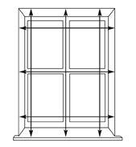

Measuring Blinds to fit inside a Recess
- Measure the width and the drop in 3 positions, noting any protrusions such as dado rails and tiles.
- Make a note of the smallest width and drop measurement in cm for Roman blinds or mm for roller, venetian and vertical blinds.
- Please choose 'recess size' when placing your order and we will make the necessary adjustments to allow the blind to fit the recess.
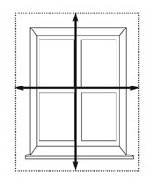

Measuring Blinds to fit outside a Recess
- Allow the blind to extend approximately 50-100mm above and below the window and 50-100mm either side.
- Make a note of the required width and drop in cm for Roman blinds or mm for roller, venetian and vertical blinds.
- Please quote 'blind size' when placing your order. This is the size we will make the blind.
When measuring for blinds please use a metal tape measure as cloth or plastic tape measures may stretch. Always quote sizes in centimetres for Roman blinds.
Kind regards,
NANA ROBIN DESIGNS

